Four Pillars Multi-Event Challenge

12th January 2019
Doncaster Athletics Track
Tom Kelly Reserve
George Street, Doncaster
****************************************************
Program commences at 9:00 am for U6—U16
- U6—U7 4 events + skills training/shuttle relays
- U8—U16 5 events
- All athletes must wear their Subway rego patch
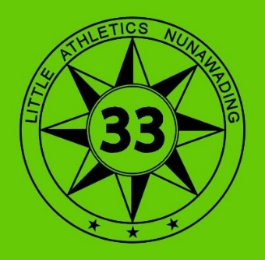
- Your Centre uniform is encouraged but optional
- Trophies to 1st, 2nd & 3rd in each Age & Gender
- IAAF point score system
- Event entry & admission is free
- No protests entered into

 | U6 |  | U7 |  | U8 |  | U9 |  | U10 |  | U11 |  | U12-13 |  | U14 - U16
 | G B |  | G B |  | G B |  | G B |  | G B |  | G B |  | G B |  | G B
1 | 300 | 300 | SP | 300 | 400 | LJ | SP | DISC | SP | LJ | 100 | 100 | LJ | DISC | 100 | 100
2 | SP | ST | 300 | 100 | LJ | 100 | LJ | LJ | 100 | DISC | LJ | 60H | 80H | 80H | 80/90H | 90/100H
3 | 100 | 100 | 100 | SP | 60H | 400 | 100 | 60H | 60H | 60H | 60H | 800 | 100 | 100 | SP | LJ
4 | ST | SP | ST | ST | 100 | 60H | 60H | 100 | LJ | 100 | 800 | LJ | SP | 800 | 800 | 800
5 | LJ | LJ | LJ | LJ | SP | DISC | 800 | 800 | 800 | 800 | SP | DISC | 800 | LJ | LJ | DISC

